# CS 255 System Design Document

## UML Diagrams

### UML Use Case Diagram

*[In Module Six, you were asked to complete a use case diagram based on your system design. If you would like to make any adjustments to your diagram, please do so. Please insert your use case diagram here. Check to make sure that you included appropriate components and symbols and that your design*

*meets the client’s needs.]*

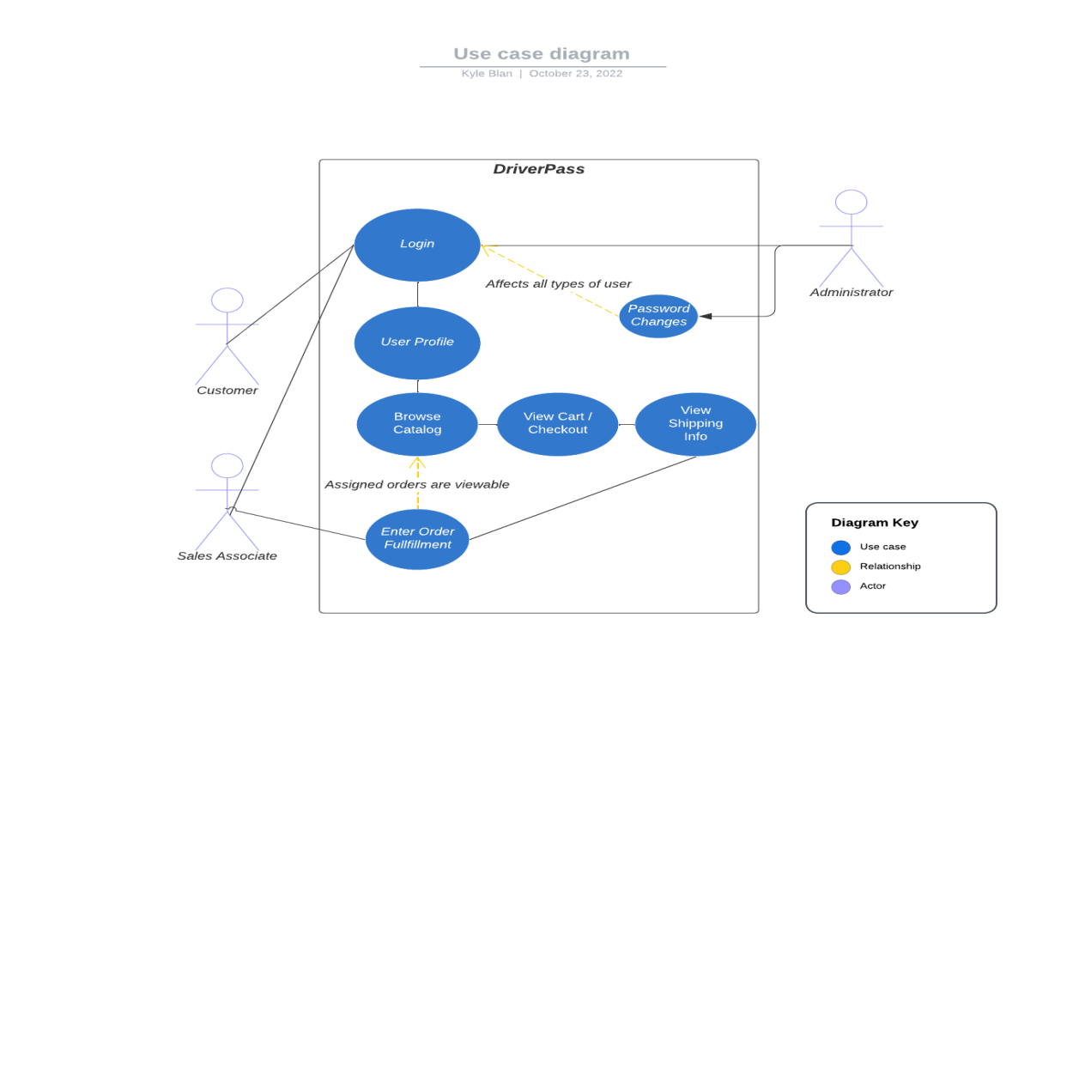

### UML Activity Diagrams

*[You were asked to choose* ***two*** *use cases and create* ***two*** *activity diagrams, one for each use case. Please insert* ***both*** *of your activity diagrams here. Check to make sure that you included appropriate components and symbols and that your design meets the client’s needs.]*

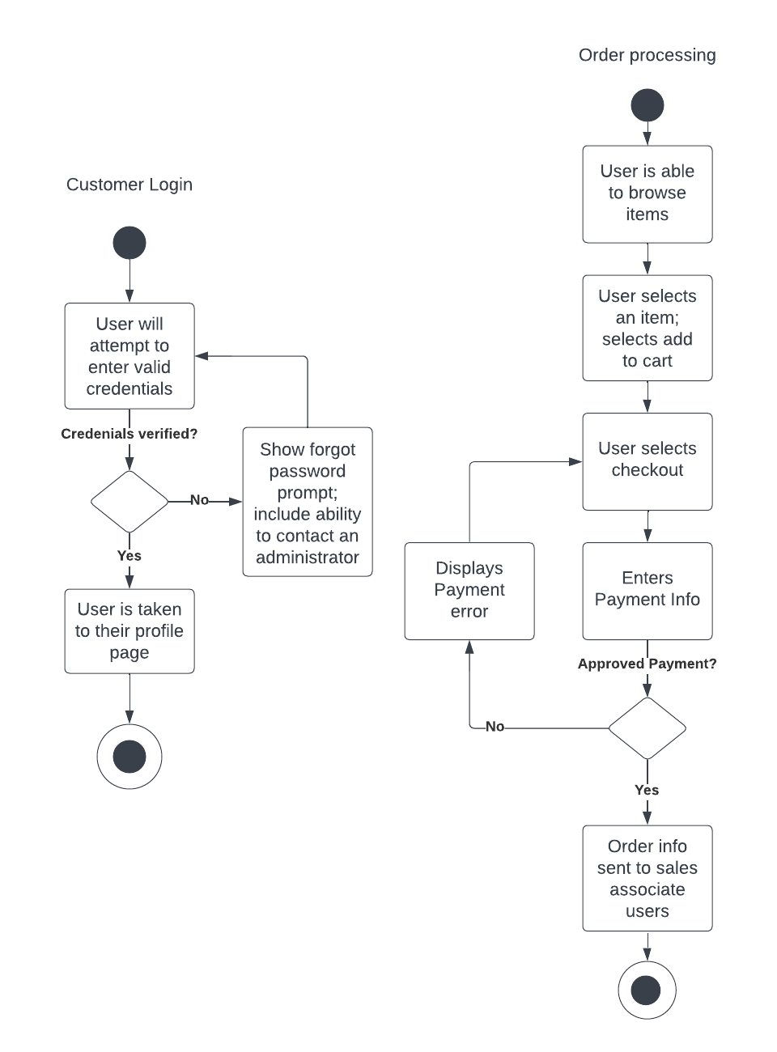

### UML Sequence Diagram

*[You were asked to create a sequence diagram based on* ***one*** *of the use cases you chose. Please insert your sequence diagram here. Check to make sure that you included appropriate components and symbols and that your design meets the client’s needs.]*

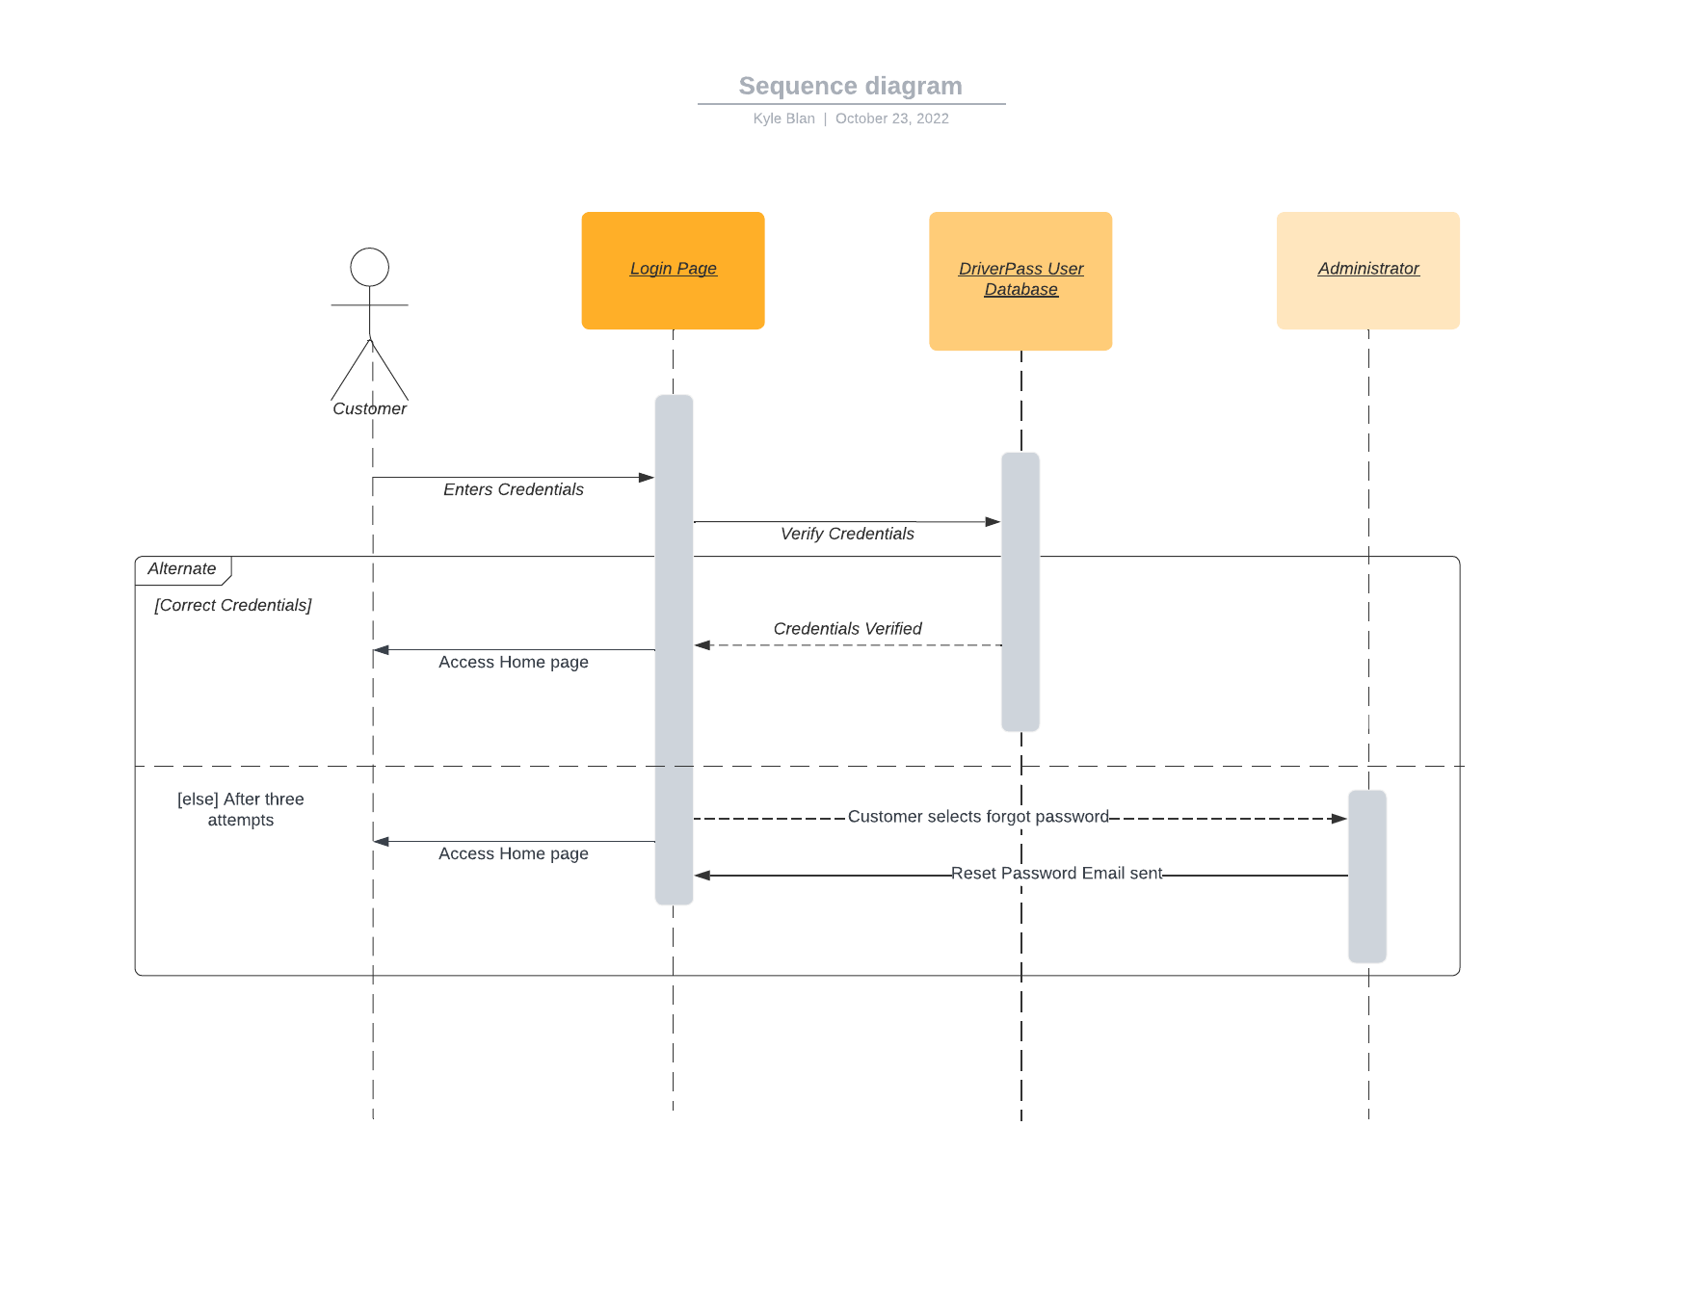

### UML Class Diagram

*[You were asked to create a class diagram based on the different classes and attributes needed for your system design. You are* ***not*** *required to include methods, but you may if you wish. Please insert your class diagram here. Check to make sure that you included appropriate components and symbols and that your design meets the client’s requirements.]*

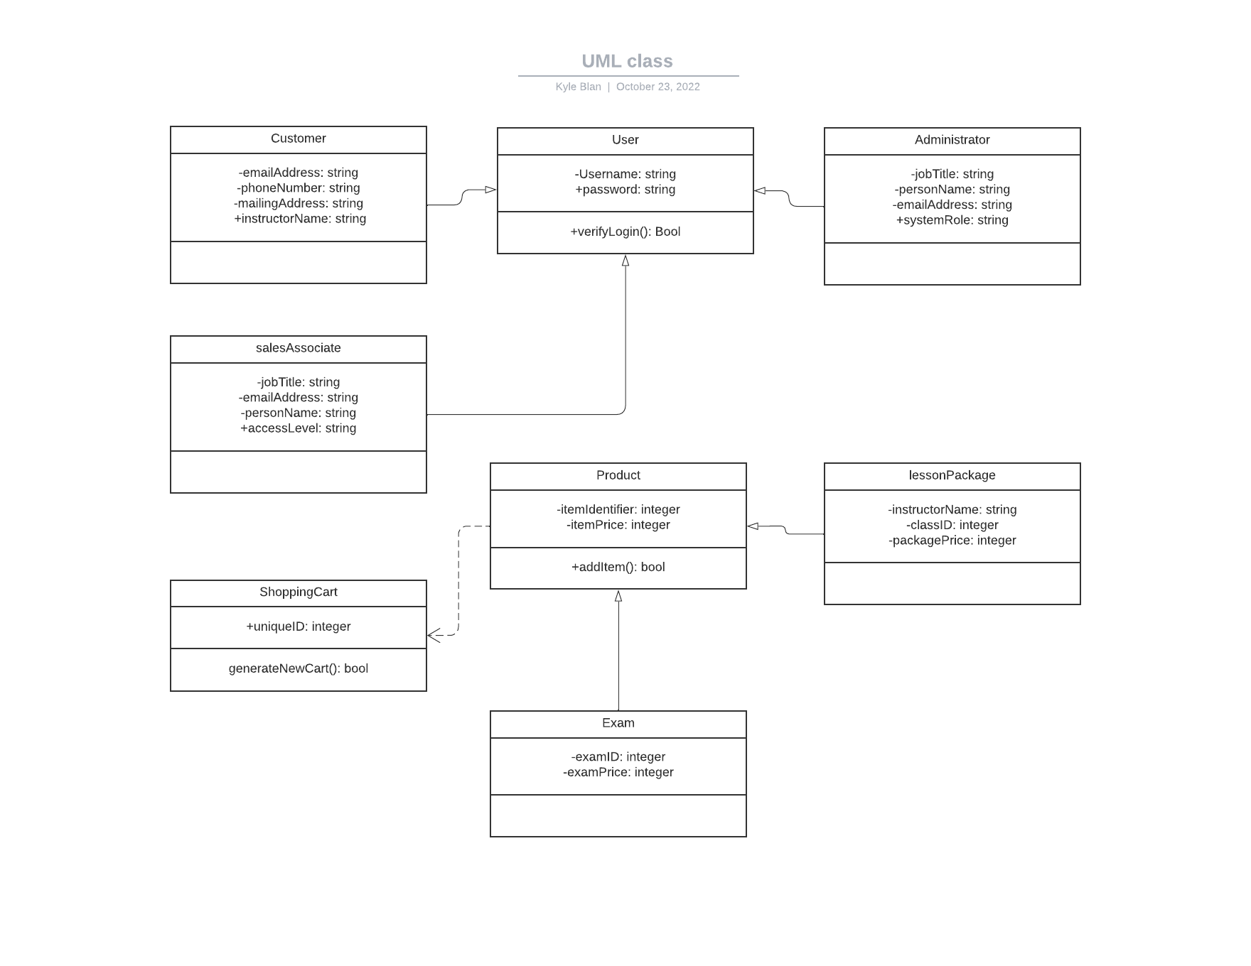

## Technical Requirements

*[Based on the diagrams you have created, describe the technical requirements of your system. These requirements should address the required hardware, software, tools, and infrastructure necessary for your system design.]*

This system will require multiple databases to contain both customer and proprietary data, and including server allocations to host this data to the customer. The end user will require an internet connected computer capable using a modern browser environment, and that is capable of running the required browser plugins of the learning content format. This would likely take the form of a video player, but must be flexible to adapt to the content creators.